**Full Stack Development with MERN**

**Database Design and Development Report**

|  |  |
| --- | --- |
| Date | 11 July 2024 |
| Team ID | SWTID1720171927 |
| Project Name | SBFoods- Food Ordering Website |
| Maximum Marks | 5 Marks |

**Project Title**: SBFoods- Food Ordering Website

**Date**: 11 July 2024

**Prepared by**: SWTID1720171927

**Objective**

The objective of this report is to outline the database design and implementation details for the SBFoods project, including schema design and database management system (DBMS) integration.

**Technologies Used**

* **Database Management System (DBMS):** MongoDB
* **Object-Document Mapper (ODM):** Mongoose

**Design the Database Schema**

The database schema is designed to accommodate the following entities and relationships:

**1. Users:**

• Schema: userSchema

• Represents the user data and includes fields such as username, email, password and cart details.

**2. Menu Items:**

• Schema: foodSchema

• Represents the data of all the products in the platform.  It is used to store information about the product details – name, description, price, image category; which will later be useful for ordering.

**3. Orders:**

• Schema: orderSchema

• Represents the orders placed on the platform. The schema stores user id, dished ordered, total amount, delivery address, date of the order placed, order status and payment.

**Implement the Database using MongoDB**

Database name: SbFoods

The MongoDB database is implemented with the following schemas:

foodSchema:

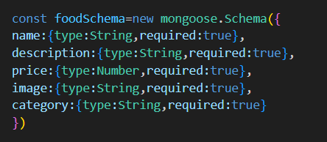

userSchema:

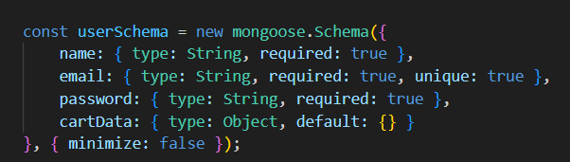

orderSchema:

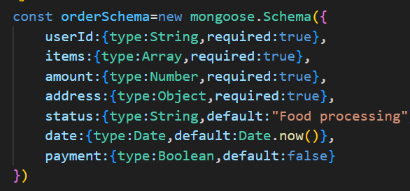

**Integration with Backend**

* Database connection:

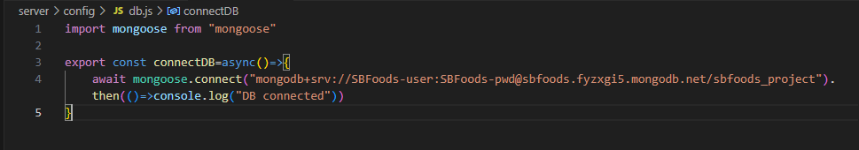

* The backend APIs interact with MongoDB using Mongoose ODM Key interactions include:

1. User Management:

- CRUD operations for users.

- User authentication and authorization.

2. Menu Management:

- CRUD operations for menu items.

- Display menu items to users.

3. Order Management:

- CRUD operations for orders with user authentication.

- Order tracking and status updates.

5. Cart Management:

- CRUD operations for cart items.

- Calculate total amount in the cart.

6. Admin Management:

- CRUD operations for admin users.

- Admin authentication and role management.